SIMATS ENGINEERING (SAVEETHA SCHOOL OF ENGINEERING)

Department of Computer Science and Engineering
CO2 ASSESSMENT TOOL 2 – Architecture Design Assignment

Course Code: | CSA10 | Course Title: | Software Engineering
CO Assessed: | CO2 | Assessment: | Assessment Tool 2 – Architecture Design Assignment
Weightage: | 20% | Total Marks: | 25
CO2 Statement: | Perform detailed requirements analysis, design scalable architectures, and prioritize features with a focus on cross-disciplinary skills
Student Name: | Boddu Ramya | Reg. No.: | 192424183
Date: | 05/08/2026 | Duration: | 60 minutes
Code of Conduct
I Boddu Ramya(192424183)(Name / Reg No) certify that this submission is my original work and that I have adhered to the guidelines specified for this assessment. I understand that any violation of academic integrity rules will result in disciplinary action.
Signature of the Student: Ramya
Annexure A – Architecture Design Assignment

Instructions to Students:

Each student will be assigned an individual software project problem statement. Based on the assigned problem, analyze the system requirements and design an appropriate software architecture by applying software engineering principles. Your submission should demonstrate your ability to select, justify, and evaluate a suitable architectural style.

Question

Based on your assigned problem statement, perform an Architecture Design Analysis and prepare an architecture design report by answering the following questions:

Analyze System Requirements

  - Study the given problem statement and identify the system objectives.
  - Analyze the functional and non-functional requirements that influence the software architecture.
  - Identify key quality attributes such as scalability, maintainability, reliability, availability, performance, and security.

Select a Suitable Software Architecture

  - Select an appropriate architectural style for the proposed system (e.g., Layered Architecture, Client-Server, MVC, Microservices, Event-Driven, Service-Oriented Architecture, Serverless, or Hybrid Architecture).
  - Justify why the selected architecture is the most suitable for the given problem.

Draw the Software Architecture Diagram

  - Design a clear architecture diagram illustrating the overall structure of the proposed system.
  - Include all major layers/components, databases, external systems, APIs, and communication mechanisms.
  - Use appropriate software architecture notations and labels.

Explain Components and Their Interactions

  - Describe the purpose and responsibilities of each architectural component.

  - Explain how the components communicate and exchange data.
  - Illustrate the overall workflow of the system.

Discuss Quality Attributes
Evaluate how the proposed architecture addresses the following aspects:

  - Scalability
  - Security
  - Performance
  - Reliability
  - Maintainability
  - Availability

Justify Architectural Decisions

  - Explain the rationale behind your architectural choices.
  - Discuss the trade-offs considered while selecting the architecture.
  - Explain how the chosen architecture supports future enhancements, system integration, and long-term maintainability.

Rubrics for Calculation
Evaluation Criteria | Excellent (4 Marks) | Good (3 Marks) | Satisfactory (2 Marks) | Needs  Improvement (1 Mark)
System  Requirement Analysis | Thoroughly analyzes the problem statement, accurately identifies functional and non-functional requirements, and clearly explains quality attributes influencing the architecture. | Analyzes most  requirements with minor omissions or limited explanation. | Identifies only basic  requirements with partial analysis. | Requirement analysis is incomplete, inaccurate, or lacks clarity.
Selection of Software  Architecture | Selects the most appropriate architectural style  with strong technical justification aligned to system requirements. | Selects a suitable architecture with reasonable justification. | Architecture is partially  suitable with limited justification. | Inappropriate architecture selected or justification is missing.
Architecture Diagram and Component Design | Produces a clear, complete, and well-structured  architecture diagram with all major components, interfaces, and  interactions accurately represented. | Diagram is mostly complete with minor omissions or notation issues. | Diagram  includes only essential  components and lacks sufficient detail. | Diagram is incomplete, unclear, or technically incorrect.

Component Interaction and Quality  Attribute Analysis | Clearly explains component responsibilities, interactions, and thoroughly discusses scalability, security, performance, reliability, maintainability, and availability. | Explains most  components and quality attributes with minor gaps. | Provides limited explanation of  interactions and addresses only some quality attributes. | Component  interactions and quality  attributes are poorly explained or missing.
Architectural Justification and Technical Presentation | Provides strong justification for architectural decisions, discusses trade-offs and future enhancements, and presents a  well-organized, professional report. | Provides adequate justification with minor gaps; report is well organized. | Limited justification with minimal discussion of trade-offs or future scope; report needs  improvement. | Justification is weak or absent; report lacks organization and technical clarity.

Criteria | Mark
System Requirement Analysis | /5
Selection of Software Architecture | /5
Architecture Diagram and Component Design | /5
Component Interaction and Quality Attribute Analysis | /5
Architectural Justification and Technical Presentation | /5
TOTAL | /5

NAME:BODDU RAMYA REG.NO:192424183

COURSE CODE & NAME:CSA1013- SOFTWARE ENGINEERING

QUESTION:

12. Smart Pharmacy Inventory and Medicine Expiry Management Platform

1. ANALYZE SYSTEM REQUIREMENTS

1.1 System Objectives
The main objectives of the Smart Pharmacy Inventory and Medicine Expiry Management Platform are:
Manage medicine inventory efficiently.
Track medicine quantities and batch numbers.
Monitor medicine expiry dates.
Generate low-stock and expiry alerts.
Manage medicine purchases and sales.
Generate bills and reports.
Maintain secure pharmacy data.
Reduce medicine wastage and manual work.
Provide reliable and easy access to pharmacy information.

1.2 Functional Requirements

The system should provide the following functions:
User registration and login.
Role-based user access.
Medicine management.
Inventory management.
Supplier management.
Purchase management.
Sales and billing.
Medicine batch and expiry tracking.
Low-stock alerts.
Expiry alerts.
Search and filter medicines.
Report generation.
Customer management.
Data backup and recovery.

1.3 Non-Functional Requirements
Performance: The system should respond quickly to user requests.
Security: User and pharmacy data must be protected.
Scalability: The system should support increasing medicines, users, and transactions.
Reliability: The system should maintain accurate data.
Availability: The system should be available during pharmacy operating hours.
Maintainability: The system should be easy to modify and maintain.
Usability: The interface should be simple and user-friendly.

1.4 Key Quality Attributes
The major quality attributes are:
Scalability
Security
Performance
Reliability
Maintainability
Availability

SELECT A SUITABLE SOFTWARE ARCHITECTURE

Selected Architecture

Layered Client-Server Architecture
The proposed system uses a Layered Client-Server Architecture with the following major layers:
Presentation Layer
Application/Business Logic Layer
Data Access Layer
Database Layer
External Services

2.2 Justification
Layered Client-Server Architecture is suitable because:
It separates the user interface from business logic and data.
It is simple to design and implement.
It is easy to maintain and test.
Security can be implemented at different layers.
The database can be modified without major changes to the user interface.
New features can be added easily.
It is suitable for small and medium-sized pharmacies.
It can later be extended to support multiple pharmacy branches.

3. SOFTWARE ARCHITECTURE DIAGRAM
The architecture diagram should contain the following components:
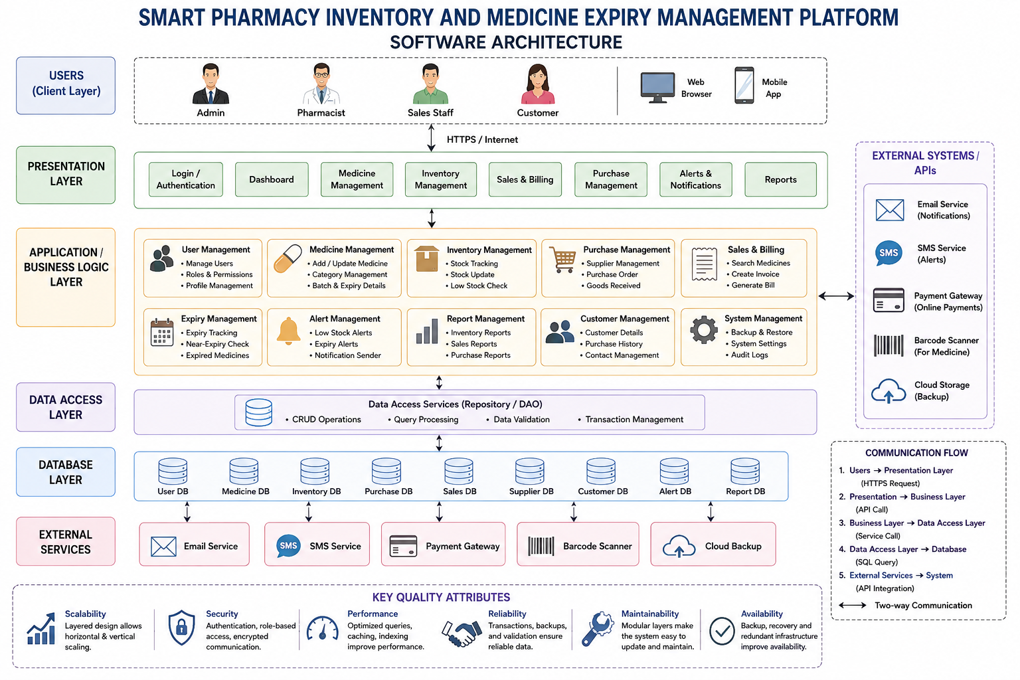

Communication Mechanisms
Users communicate with the system through Web/Mobile UI.
Client and server communicate using HTTPS.
Presentation Layer communicates with the Business Layer using APIs.
Business Layer communicates with the Data Access Layer.
Data Access Layer communicates with the database using SQL/ORM.
Alert Management communicates with SMS/Email services.
Payment processing communicates with an external Payment Gateway.

4.COMPONENTS AND THEIR INTERACTIONS

4.1 Presentation Layer

Purpose
Provides the interface through which users interact with the system.

Responsibilities

Login page
Dashboard
Medicine management
Inventory screen
Sales and billing
Purchase management
Alerts
Reports

Users
Admin
Pharmacist
Sales Staff
Customer

4.2 Authentication and Authorization Component

Purpose
Controls system access.

Responsibilities
User login
Password verification
User authentication
Role-based access
Session management
Example roles:
Admin → Full access
Pharmacist → Inventory and medicine access
Sales Staff → Sales and billing access
Customer → Limited access

4.3 Medicine Management Component

Purpose
Manages medicine information.

Responsibilities
Add medicine
Update medicine
Delete medicine
Search medicine
Store batch number
Store expiry date
Store manufacturer information

4.4 Inventory Management Component

Purpose
Maintains current medicine stock.

Responsibilities
Track available quantity.
Increase stock after purchase.
Decrease stock after sale.
Check minimum stock level.
Generate low-stock alerts.

4.5 Purchase Management Component

Purpose
Manages medicine purchases from suppliers.

Responsibilities
Store supplier details.
Record purchase orders.
Record purchased medicines.
Update inventory after purchase.
Maintain purchase history.

4.6 Sales and Billing Component

Purpose
Handles medicine sales.

Responsibilities
Search medicines.
Check stock availability.
Record sales.
Calculate total price.
Generate bills.
Update inventory.

4.7 Expiry and Alert Management Component

Purpose
Tracks medicine expiry and creates notifications.

Responsibilities
Check expiry dates.
Identify near-expiry medicines.
Identify expired medicines.
Generate expiry alerts.
Generate low-stock alerts.
Send notifications.

4.8 Reporting Component

Purpose
Provides useful information for pharmacy management.

Reports
Inventory report
Sales report
Purchase report
Expiry report
Low-stock report
Supplier report

4.9 Data Access Layer

Purpose
Acts as an interface between business components and the database.

Responsibilities
Insert data
Retrieve data
Update data
Delete data
Execute database queries
Maintain data consistency

4.10 Database Layer
Stores all important pharmacy information.

Main Data
User data
Medicine data
Inventory data
Supplier data
Customer data
Purchase data
Sales data
Expiry information
Alert information
Report information

4.11 External Services
The system may communicate with:
SMS service
Email service
Payment gateway
Barcode scanner
Cloud backup service

5. OVERALL SYSTEM WORKFLOW

Medicine Purchase Workflow
Pharmacist

Select Supplier

Enter Purchase Details

Business Logic

Update Inventory

Store in Database

Medicine Sale Workflow

Sales Staff

Search Medicine

Check Stock

Process Sale

Generate Bill

Reduce Inventory

Update Database

Medicine Expiry Workflow

System Scheduler
|

Check Expiry Dates

Identify Near-Expiry / Expired Medicines

Generate Alert

Notify Pharmacist

Update Alert Status

6. DISCUSSION OF QUALITY ATTRIBUTES

6.1 Scalability
The layered architecture allows the system to support an increasing number of:
Medicines
Users
Transactions
Suppliers
Pharmacy branches
The application server and database can be upgraded when the workload increases.

6.2 Security
Security is implemented using:
User authentication
Role-based authorization
Password protection
HTTPS communication
Database access control
Secure backups
Only authorized users can access sensitive information.

6.3 Performance
Performance is improved by:
Efficient database queries
Database indexing
Caching frequently accessed data
Separating presentation and business logic
Optimizing inventory searches

6.4 Reliability
Reliability is supported through:
Database transactions
Data validation
Regular backups
Error handling
Recovery mechanisms
This reduces the possibility of incorrect or lost inventory data.

6.5 Maintainability
The layered architecture makes maintenance easier because each layer has a specific responsibility.
For example:
UI Change
↓
Presentation Layer

Business Rule Change
↓
Business Layer

Database Change
↓
Data Access Layer
Changes in one layer have minimal impact on other layers.

6.6 Availability
The system can provide high availability through:
Reliable server infrastructure
Database backup
Recovery mechanisms
Server monitoring
Cloud hosting
Redundant infrastructure in future versions

JUSTIFICATION OF ARCHITECTURAL DECISIONS

7.1 Why Layered Architecture?
Layered Architecture was selected because the pharmacy system contains clearly separated responsibilities such as user interface, business operations, and database management.
It provides:
Simplicity
Modularity
Easy testing
Easy maintenance
Better security
Reusability
Future expansion

7.2 Why Not Microservices?
Microservices can provide high scalability but may be unnecessarily complex for a small or medium-sized pharmacy system.
They require:
Multiple services
Service communication
More deployment management
Monitoring
Higher development and maintenance effort
Therefore, Layered Architecture is more appropriate for the initial system.

7.3 Why Client-Server?
Client-Server architecture allows multiple pharmacy users to access a centralized application and database.
For example:
Admin

Pharmacist

Sales Staff Server Database

Customer
This ensures centralized data management.

ARCHITECTURAL TRADE-OFFS
Decision | Advantage | Trade-off
Layered Architecture | Simple and maintainable | Can become slower with many layers
Centralized Database | Easy data management | Database can become a single point of failure
Client-Server | Centralized access | Requires network connectivity
REST API | Easy system integration | Requires API security
Role-Based Access | Improves security | Requires permission management
Cloud Backup | Protects data | May increase operational cost

9. FUTURE ENHANCEMENTS
The architecture supports future improvements such as:
Mobile application.
Multi-branch pharmacy support.
Barcode scanning.
AI-based medicine demand prediction.
Automatic SMS/email notifications.
Online medicine ordering.
Prescription management.
Cloud deployment.
Advanced analytics dashboard.
Integration with hospital and healthcare systems.
Payment gateway integration.
Microservices migration when the system becomes very large.

10. OVERALL ARCHITECTURAL DECISION
The Layered Client-Server Architecture is the most suitable architecture for the Smart Pharmacy Inventory and Medicine Expiry Management Platform.
It separates the presentation, business logic, data access, and database responsibilities. This improves security, performance, maintainability, reliability, scalability, and availability.
The architecture is simple enough for initial implementation while providing sufficient flexibility for future enhancements such as mobile applications, cloud deployment, AI-based forecasting, multi-branch support, and external healthcare system integration.

11. CONCLUSION
The proposed architecture provides a structured and reliable solution for the Smart Pharmacy Inventory and Medicine Expiry Management Platform. The Layered Client-Server Architecture effectively handles medicine management, inventory tracking, expiry monitoring, sales, purchases, billing, alerts, and reporting.
The separation of components makes the system easier to develop, test, secure, maintain, and extend. It also supports future technologies and integrations without requiring major changes to the complete system.

